Dear Amy, thank you so much for your booking. It’s an honour to connect with your energy in this way. I intend any guidance conveyed with loving intentions for your highest possible potential and growth.

With regards to your intention please see the notes below and photo that was taken of your healing mandala, created on Friday 27th December.
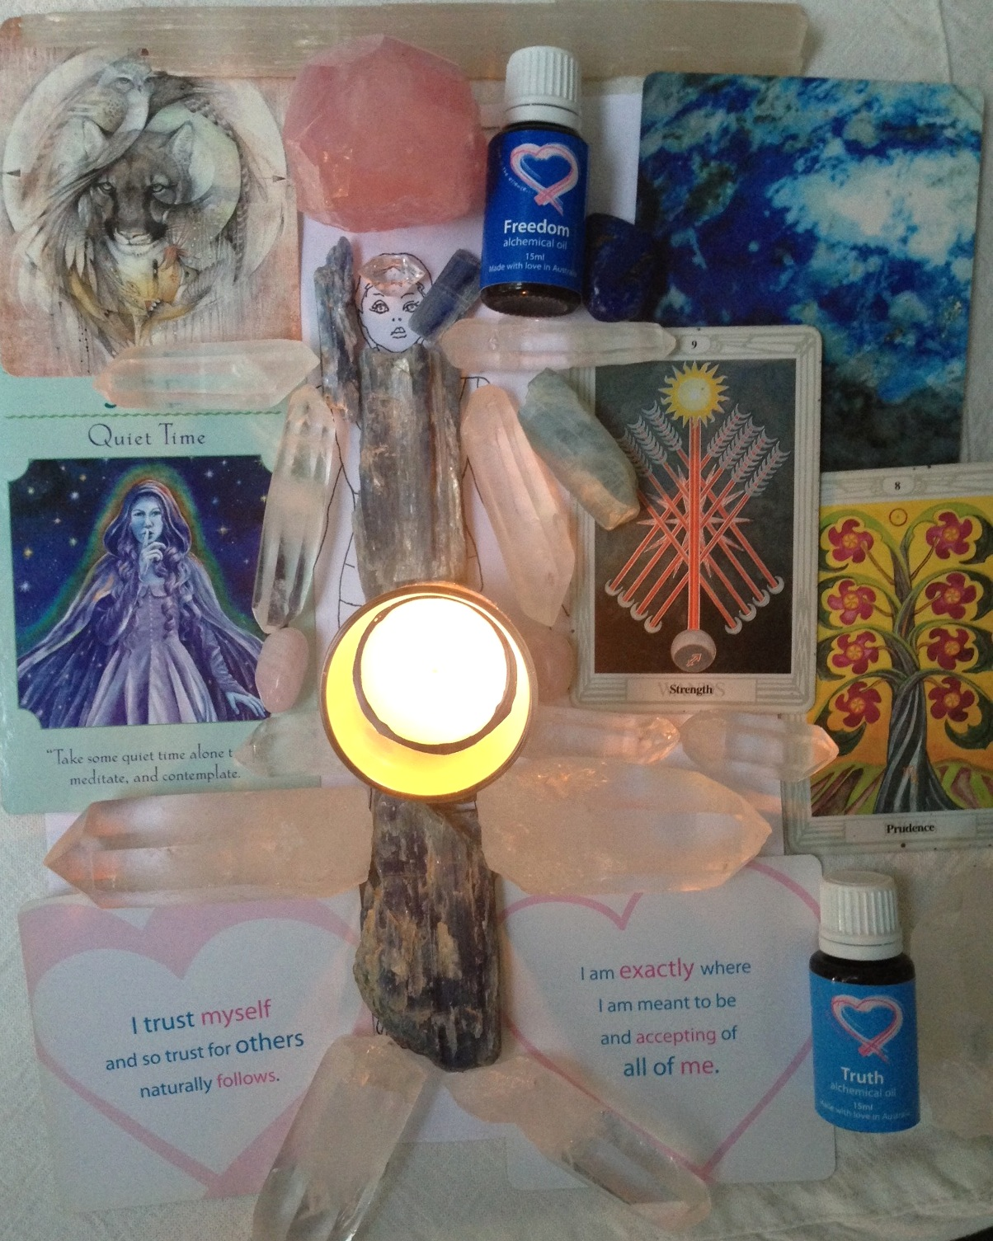

Amy, as I tune into your energy I immediately feel such an angelic resonance. Your auric field is very light and ethereal. So much shimmering pale blue, soft pink and white energies. Divine.

The next couple of months are not a time of dramatic action, rather this is a time for calm contemplation and integration. Sitting in silence and entering the void inside where all your wisdom resides. It’s a time for you to take stock. Take your time to settle into the year and don’t make rash decisions. Remind yourself there is nothing to ‘achieve’ or anywhere to ‘go’. You have already ‘arrived’.

This is reinforced by the Prudence tarot card whose message is to let things unfold in their own time. There is no need to force anything as each leaf gently unfurls revealing hidden gifts when it is time for the harvest. Rest, step aside and let life show itself to you. Relax and trust.

You have been through a period of much releasing and this will continue but more of a refining and tidying up. This has been about themes of ‘Freedom’ and ‘Truth’ and you can take these further. When we let go of so much in our lives, it creates space for so much new possibility. You will soon begin to experience some very expanded consciousness experiences and realisations.

I asked my crystals which were most relevant for you at this time and kyanite, lapis lazuli, aquamarine and clear quartz jumped out for you to clarify and balance the energy between your brow and throat chakras.

Kyanite is what Archangel Michael’s sword is made from and cuts through illusion and cords, assisting us with letting go of what and who no longer serves us. Your energy is aligned with him. Kyanite assist in opening your psychic channel even more and enhance the ability to ‘download’ and receive wisdom. It builds bridges of light and promotes communication with the divine and cuts through confusion, clouded thoughts or indecisiveness. Kyanite will assist you in dissolving what is not in alignment with your truth.

Lapis Lazuli will assist you in connecting more deeply with your inner vision and truth and this stone of visionary awareness will also stimulate your brow and throat chakras. It also teaches discernment in truth and harmonises you with your highest truths. Aquamarine is smoothing the communication pathway between your heart and throat chakras, encouraging you express even more heart-felt communication.

You can meditate and say ‘I invoke the pure consciousness of lapis lazuli into my brow chakra now to support me with ease and grace. I claim my highest truth and the full sovereignty of my Being.’

Amy, you are a very clear channel and there is much writing ahead of you. I see a book waiting to be brought into form. Archangel Gabriel, one of the Archangels of communication will assist you with this if you call upon him. He is merely waiting to be asked.

I feel you would benefit greatly from doing The Artist’s Way by Julia Cameron and starting 2014 with that process of the morning pages. There are so many other creative gifts ready to come to the fore for you Amy and this will bring more into your awareness. There is more creative energy ready to be released and shared with the world. A course with “The Writer’s Studio” would also be beneficial for you and you can do in person or online.

This is reinforced by the Strength tarot card, which indicates the integration of the light and dark. Dormant powers are awakened and ready to be directed in a conscious way. This can also mean resolving anything outstanding that you have avoided facing too. As you surrender to unfolding your highest potential, all aspects must be brought out into the open to be accepted and acknowledged.

Lapis Lazuli vibrational gem essence from www.humanifest.com.au would also assist you at this time. This essence assists in the integration of realisations and perceptions of wisdom and our physical bodies. A process which triggers healing on all levels. The essence is very grounding yet acts to assist in the integration of spiritual, emotional or mental realisation. This process is very freeing to the throat chakra. As our realisations and perceptions are integrated the throat opens and offers a pathway of balance between the throat chakra and the other chakras especially the third eye. This is the action of this essence. This process assists in personal and spiritual expression through voice and the other forms of expression

The animal totem of Puma came forward for you. Puma represents powerful magic and an awakening of energies and desires leading to healing and fulfilment.
I invite you to ask yourself:
- What are my deepest desires?
- What am I ready to explore creatively?
- What have I been putting off that I really want to explore?
- What is my highest truth and how can I embody that more deeply?
- Am I fearful of my own power and do I keep it small?
The Diana Cooper Angel meditations, including Archangel Gabriel are at the link I sent you. You can listen to this for FREE on Spotify. You may have some interruption with ads, so it’s actually worth paying for a month of ad-free time, which is about $7. Or you can always download from itunes.

The 2 self-love cards for you are:
- I trust myself and so trust for others naturally follows.
- I am exactly where I am meant to be and accepting of all of me.

In terms of Alchemical oils that would most support this process, the following 2 would be ideal:

Freedom: I set myself free
Supports in releasing self-imposed limitations and perceptions. Where are you holding yourself back with your thinking about what is possible for you? Where can you set yourself free? What would it mean to expand your comfort zone?

Truth: I express my truth with love
Expressing heart-felt communication and opening the throat chakra, the gatekeeper to the heart’s voice. A reminder that your truth is only true for you and that you have no control over how this is received. Truth dissolves blocks between the heart and throat chakras.

I would like to offer you these (and any others you feel drawn to at the wholesale price for the next 14 days at $30 each, rather than $49). These will support you in integrating this energy process over the coming weeks.

This energy mandala will remain for 3 days. I suggest that you set aside at least one hour in the next couple of days to lie down and receive.

Make sure that you won’t be disturbed by anyone and that your phone is turned off. Ensure that the room is clean and tidy so that you can just relax and are not distracted by anything. Burn incense or light a candle and dedicate it to your healing time. If you have a few hours to yourself, some suggestions of how you can prepare yourself are detailed here.
http://michellemariemcgrath.com/5-favourite-self-love-rituals/

Lie down and make yourself comfortable. You can speak aloud “I command full sovereignty of my Being and call all of my energy fully into this moment, across all time, space, levels, layers and dimensions. So be it. I call in my healing session from Michelle and ask for this to be fully integrated into my Being with ease and grace.” Or words that you feel more comfortable expressing. You are very intuitive and you will know when it feels complete for you and the energy will continue to integrate over the coming days and months.

Thank you so much for your request Amy, it’s been a pleasure to connect with you in this way. Be gentle with yourself and give yourself some time to sit back, relax and take this in, in your own time.

Lots of love and many blessings to you for a very happy and peaceful 2014!
Michellexxxx

